Exp. No: 3
Force of Attraction between Two Electric Charges and Two Parallel Conductors Separated by Varying Distance
Test case (i) Determination and plotting of force between two electric charges with varying distance
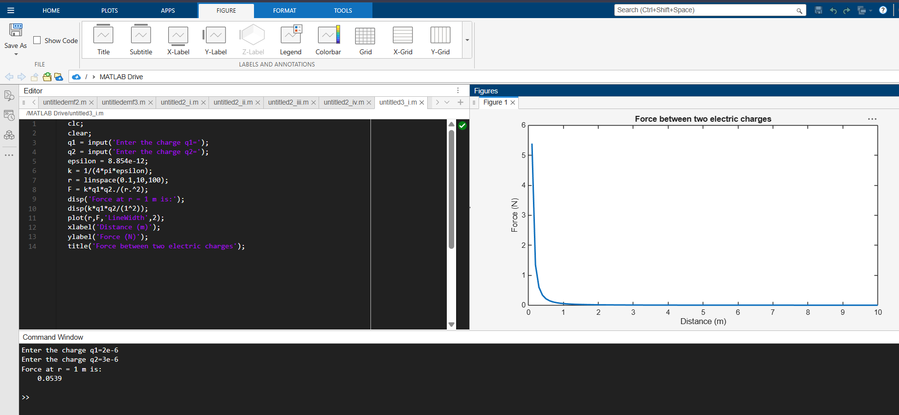
Test case (ii) Determination and plotting of force between two electric charges with different magnitudes
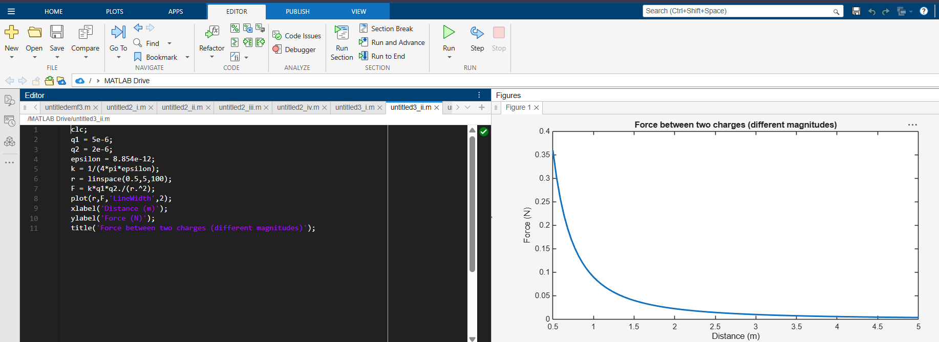

Test case (iii) Determination and plotting of force per unit length between two parallel conductors with varying distance
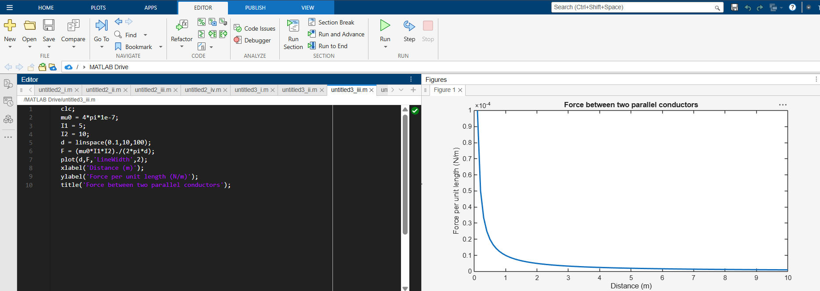
Test case (iv) Determination and plotting of force between two parallel conductors carrying equal currents
